HES PTA Sponsored Chess-Bee Academy
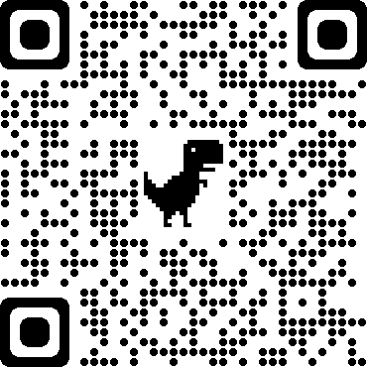
with Snow’s Chess Academy Winter 2023
Grades 2 – 6
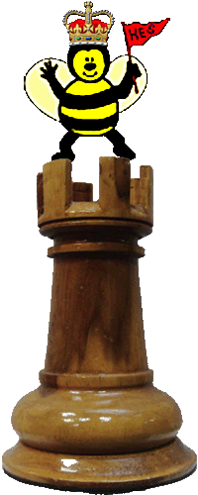

Mix of instructional time and active Chess play!
Beginners to Grandmasters welcome … Something for everyone!

Thursday: 1/19 – 3/16 8:10 am – 9:10 am Cost: $70 / child for 8 lessons
Location: Cafeteria/Library
*NO CLASS 1/26
Questions? Contact Morganna Elasky - herndonesptaclubs@gmail.com

Register online at https://herndonespta.com/clubs/chess-academy/ or Return this form with check payable to HES PTA to your child’s teacher.

Student: Teacher: Grade:
□ Student is in morning SACC.
Allergies or Special Conditions:
Parent/Guardian: Email:
If not available, in an emergency, notify:
Name Phone:

Parent Signature: Date:

*These materials are neither sponsored nor endorsed by the Fairfax County School Board, the Superintendent, or this school. This program is approved by the HES PTA.

